Official league roster – SOCCER 2022

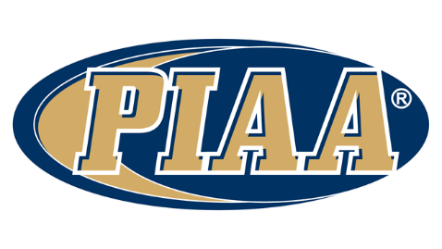

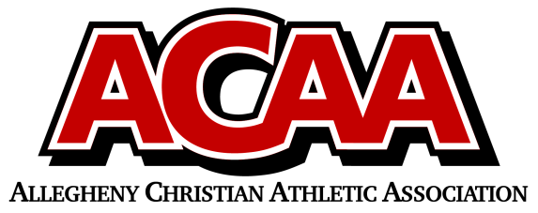

School Name: Meadowbrook Christian

Team Colors: Forest Green / White

Overall Wins ___ Losses ____ Ties ___

ACAA Wins ___ Losses ____ Ties ___ OPPONENT: __________________________

Date: _________

|  |  |  |  |  |  |
| --- | --- | --- | --- | --- | --- |
|  | **Name** | **Year** | **Position** | **Height** | **Homeschool** |
| 23 | Josh Bakowicz | 12th | MID |  |  |
| 29 | Nick Bennage | 12th | DEFENSE |  |  |
| 0 | Matt Schmit | 12th |  |  |  |
| 11 | Jayar Rhoades | 12th | DEFENSE |  |  |
| 13/0 | Josiah Baker | 11th | GK/Defense |  |  |
| 5 | Levi Erb | 11th | DEFENSE |  |  |
| 22 | Garrett Knopp | 11th | MID |  |  |
| 14 | Luke Osman | 11th | STRIKER |  |  |
| 16 | Nick Peachy | 11th |  |  |  |
| 6 | Joah Robel | 11th | DEFENSE |  |  |
| 2 | Austin Steck | 11th | MID |  |  |
| 40 | Danny Yoder | 11th |  |  |  |
| 37 | Alex Clark | 9th |  |  |  |
| 9 | Josiah Cruz | 9th |  |  |  |
| 4 | Ethan Steck | 9th |  |  |  |
| 3 | Austin Weikel | 9th |  |  |  |
|  |  |  |  |  |  |
|  |  |  |  |  |  |
|  |  |  |  |  |  |
|  |  |  |  |  |  |
|  |  |  |  |  |  |
|  |  |  |  |  |  |
|  |  |  |  |  |  |

VARSITY BOYS

Head Coach: Matt Steck

Asst. coach: Collin Erb

Asst. coach: Jeremy Rhoades

Asst. coach: Autumn Steck

Athletic Director: Samantha DeLong

Official ACAA League Team Roster. to be submitted to the scorer’s table before each game.